CQ Version 7 Migration Activity – 21st and 22nd March 2009

Login to Astra Server

Start -> cmd -> Run -> Mstsc : 192.168.220.149 ASTRA Server

Login: asamsit
Pwd: Wipro@123

Copy and Paste Long2Clob installation directory in Desktop.

Start -> Run -> cmd

C:\Documents and Settings\asamsit\Desktop\long2clob>long2clob -u mastersit -p 84tipo -db astra -s 192.168.22.183 lock

*** Oracle Error: ORA-28000samsit\Desktop\long2clob>long2clob -u mastersit -p 84tipo -db astra -s 192.168.22.183 lock

pdsql -u "mastersit" -p "84tipo" -s "192.168.22.183" -db "astra" -v "ora" -errors_are_fatal -noprompt
select count(*) DaCount_COLHEAD from user_tables where table_name = 'MASTER_DBS';
EXCEPTION: [DataDirect][ODBC Oracle Wire Protocol driver]Optional feature not implemented.
[DataDirect][ODBC Oracle Wire Protocol driver][Oracle]ORA-28000: the account is locked
[DataDirect][ODBC Oracle Wire Protocol driver]Driver's SQLSetConnectAttr failed.
State: HYC00 Native: 0
Connect String used: Driver={Rational DataDirect Oracle Wire Protocol};UID=mastersit;PWD=******;HostName=192.168.22.183;PortNumber=1521;SID=astra

Long2clob::PDSQL::pdsql('Long2clob::PDSQL=HASH(0x1da1944)', 'select count(*) DaCount_COLHEAD from user_tables where table_nam...') called at C:/Documents and Settings/asamsit/Desktop/long2clob/Long2clob/PDSQL.pm line 304
Long2clob::PDSQL::pdsql_select('Long2clob::PDSQL=HASH(0x1da1944)', 'select count(*) DaCount_COLHEAD from user_tables where table_nam...', 1) called at C:/Documents and Settings/asamsit/Desktop/long2clob/Long2clob/PDSQL.pm line 378
Long2clob::PDSQL::is_schema_repo('Long2clob::PDSQL=HASH(0x1da1944)') called at C:/Documents and Settings/asamsit/Desktop/long2clob/Long2clob/PDSQL.pm line 407
Long2clob::PDSQL::is_long_database('Long2clob::PDSQL=HASH(0x1da1944)') called at C:/Documents and Settings/asamsit/Desktop/long2clob/Long2clob/Operations.pm line 150
Long2clob::Operations::get_conversion_status('Long2clob::Operations=HASH(0x1d9c864)') called at C:/Documents and Settings/asamsit/Desktop/long2clob/Long2clob/Subcommand.pm line 69
Long2clob::Subcommand::cmd_lock('Long2clob::Subcommand=HASH(0x152f1a4)') called at long2clob.bat line 355

Note: ORA-28000: the account is locked

Solution: Unlock the Mastersit DATABASE.

SQL> select username,account_status from user_users;

USERNAME ACCOUNT_STATUS
------------------------------ --------------------------------
MASTERSIT LOCKED

bash-3.00$ sqlplus

SQL*Plus: Release 10.2.0.1.0 - Production on Sat Mar 21 11:54:12 2009

Copyright (c) 1982, 2005, Oracle. All rights reserved.

Enter user-name: scott
Enter password:

Connected to:
Oracle Database 10g Enterprise Edition Release 10.2.0.1.0 - 64bit Production
With the Partitioning, OLAP and Data Mining options

SQL> connect as sysdba
Enter user-name: mastersit
Enter password:
Connected.
SQL> select username,account_status from dba_users where username='MASTERSIT';

USERNAME ACCOUNT_STATUS
------------------------------ --------------------------------
MASTERSIT LOCKED(TIMED)

SQL>
SQL> alter user MASTERSIT account unlock;

User altered.

SQL> select username,account_status from user_users;

USERNAME ACCOUNT_STATUS
------------------------------ --------------------------------
MASTERSIT OPEN

SQL> select username,account_status from dba_users where username='MASTERSIT';

USERNAME ACCOUNT_STATUS
------------------------------ --------------------------------
MASTERSIT OPEN

C:\Documents and Settings\asamsit\Desktop\long2clob>long2clob -u mastersit -p 84tipo -db astra -s 192.168.22.183 lock
*** Oracle Error: ORA-01017
pdsql -u "mastersit" -p "84tipo" -s "192.168.22.183" -db "astra" -v "ora" -error
s_are_fatal -noprompt
select count(*) DaCount_COLHEAD from user_tables where table_name = 'MASTER_DBS'
;
EXCEPTION: [DataDirect][ODBC Oracle Wire Protocol driver]Optional feature not im
plemented.
[DataDirect][ODBC Oracle Wire Protocol driver][Oracle]ORA-01017: invalid username/password; logon denied
[DataDirect][ODBC Oracle Wire Protocol driver]Driver's SQLSetConnectAttr failed.
State: HYC00 Native: 0
Connect String used: Driver={Rational DataDirect Oracle Wire Protocol};UID=maste
rsit;PWD=******;HostName=192.168.22.183;PortNumber=1521;SID=astra
Long2clob::PDSQL::pdsql('Long2clob::PDSQL=HASH(0x20216a4)', 'select coun
t(*) DaCount_COLHEAD from user_tables where table_nam...') called at C:/Document
s and Settings/asamsit/Desktop/long2clob/Long2clob/PDSQL.pm line 304
Long2clob::PDSQL::pdsql_select('Long2clob::PDSQL=HASH(0x20216a4)', 'sele
ct count(*) DaCount_COLHEAD from user_tables where table_nam...', 1) called at C
:/Documents and Settings/asamsit/Desktop/long2clob/Long2clob/PDSQL.pm line 378
Long2clob::PDSQL::is_schema_repo('Long2clob::PDSQL=HASH(0x20216a4)') cal
led at C:/Documents and Settings/asamsit/Desktop/long2clob/Long2clob/PDSQL.pm li
ne 407
Long2clob::PDSQL::is_long_database('Long2clob::PDSQL=HASH(0x20216a4)') c
alled at C:/Documents and Settings/asamsit/Desktop/long2clob/Long2clob/Operation
s.pm line 150
Long2clob::Operations::get_conversion_status('Long2clob::Operations=HASH
(0x201c8bc)') called at C:/Documents and Settings/asamsit/Desktop/long2clob/Long
2clob/Subcommand.pm line 69
Long2clob::Subcommand::cmd_lock('Long2clob::Subcommand=HASH(0x182f184)')
called at long2clob.bat line 355

Note: ORA-01017: invalid username/password; logon denied
Solution: Provide correct USERNAME and PASSWORD

USERNAME: mastersit
PASSWORD: wipro123

C:\Documents and Settings\asamsit\Desktop\long2clob>long2clob -u mastersit -p wipro123 -db astra -s 192.168.22.183 lock

New status: LOCKED

See the 'initialize' subcommand to plan conversion operations.

C:\Documents and Settings\asamsit\Desktop\long2clob>long2clob -u mastersit -p wipro123 -db astra -s 192.168.22.183 initialize
Analyzing: MASTER_DBS
Planning: REQUIRED INDEX_RENAME MASTER_DBS_IDS,MASTER_DBS_IDS_LONG
Planning: REQUIRED INDEX_RENAME MASTER_DBS_NAME,MASTER_DBS_NAME_LONG
Planning: REQUIRED TABLE_RENAME MASTER_DBS,MASTER_DBS_LONG
Planning: REQUIRED TABLE_CREATE MASTER_DBS
Planning: REQUIRED INDEX_CREATE MASTER_DBS_IDS
Planning: REQUIRED INDEX_CREATE MASTER_DBS_NAME
Planning: REQUIRED TABLE_INSERT MASTER_DBS
Planning: REQUIRED TABLE_DROP MASTER_DBS_LONG
Analyzing: MASTER_GLOBAL
Planning: REQUIRED TABLE_RENAME MASTER_GLOBAL,MASTER_GLOBAL_LONG
Planning: REQUIRED TABLE_CREATE MASTER_GLOBAL
Planning: REQUIRED TABLE_INSERT MASTER_GLOBAL
Planning: REQUIRED TABLE_DROP MASTER_GLOBAL_LONG
Analyzing: M_FORMDEF
Planning: REQUIRED INDEX_RENAME M_FORMDEF_ID,M_FORMDEF_ID_LONG
Planning: REQUIRED TABLE_RENAME M_FORMDEF,M_FORMDEF_LONG
Planning: REQUIRED TABLE_CREATE M_FORMDEF
Planning: REQUIRED INDEX_CREATE M_FORMDEF_ID
Planning: REQUIRED TABLE_INSERT M_FORMDEF
Planning: REQUIRED TABLE_DROP M_FORMDEF_LONG
Analyzing: M_PROPERTY
Planning: REQUIRED INDEX_RENAME M_PROPERTY_ID,M_PROPERTY_ID_LONG
Planning: REQUIRED TABLE_RENAME M_PROPERTY,M_PROPERTY_LONG
Planning: REQUIRED TABLE_CREATE M_PROPERTY
Planning: REQUIRED INDEX_CREATE M_PROPERTY_ID
Planning: REQUIRED TABLE_INSERT M_PROPERTY
Planning: REQUIRED TABLE_DROP M_PROPERTY_LONG
Analyzing: M_SCRIPTDEF
Planning: REQUIRED INDEX_RENAME M_SCRIPTDEF_ID,M_SCRIPTDEF_ID_LONG
Planning: REQUIRED TABLE_RENAME M_SCRIPTDEF,M_SCRIPTDEF_LONG
Planning: REQUIRED TABLE_CREATE M_SCRIPTDEF
Planning: REQUIRED INDEX_CREATE M_SCRIPTDEF_ID
Planning: REQUIRED TABLE_INSERT M_SCRIPTDEF
Planning: REQUIRED TABLE_DROP M_SCRIPTDEF_LONG
Analyzing: MASTER_OPLOG
Planning: REQUIRED INDEX_RENAME MASTER_OPLOG_INDEX,MASTER_OPLOG_INDEX_LONG

Planning: REQUIRED TABLE_RENAME MASTER_OPLOG,MASTER_OPLOG_LONG
Planning: REQUIRED TABLE_CREATE MASTER_OPLOG
Planning: REQUIRED INDEX_CREATE MASTER_OPLOG_INDEX
Planning: REQUIRED TABLE_INSERT MASTER_OPLOG
Planning: REQUIRED TABLE_DROP MASTER_OPLOG_LONG
Analyzing: MASTER_PROPERTIES
Planning: REQUIRED INDEX_RENAME MASTER_PROPERTIES_ID,MASTER_PROPERTIES_ID_
LONG
Planning: REQUIRED INDEX_RENAME MASTER_PROPERTIES_NAME,MASTER_PROPERTIES_N
AME_LONG
Planning: REQUIRED TABLE_RENAME MASTER_PROPERTIES,MASTER_PROPERTIES_LONG
Planning: REQUIRED TABLE_CREATE MASTER_PROPERTIES
Planning: REQUIRED INDEX_CREATE MASTER_PROPERTIES_ID
Planning: REQUIRED INDEX_CREATE MASTER_PROPERTIES_NAME
Planning: REQUIRED TABLE_INSERT MASTER_PROPERTIES
Planning: REQUIRED TABLE_DROP MASTER_PROPERTIES_LONG
Analyzing: SCHEMAREV_BINARIES
Planning: REQUIRED INDEX_RENAME SCHEMAREV_BINARIES_IX,SCHEMAREV_BINARIES_I
X_LONG
Planning: REQUIRED TABLE_RENAME SCHEMAREV_BINARIES,SCHEMAREV_BINARIES_LONG

Planning: REQUIRED TABLE_CREATE SCHEMAREV_BINARIES
Planning: REQUIRED INDEX_CREATE SCHEMAREV_BINARIES_IX
Planning: REQUIRED TABLE_INSERT SCHEMAREV_BINARIES
Planning: REQUIRED TABLE_DROP SCHEMAREV_BINARIES_LONG
Analyzing: SCHEMAREV_TEXTS
Planning: REQUIRED INDEX_RENAME SCHEMAREV_TEXTS_IX,SCHEMAREV_TEXTS_IX_LONG

Planning: REQUIRED TABLE_RENAME SCHEMAREV_TEXTS,SCHEMAREV_TEXTS_LONG
Planning: REQUIRED TABLE_CREATE SCHEMAREV_TEXTS
Planning: REQUIRED INDEX_CREATE SCHEMAREV_TEXTS_IX
Planning: REQUIRED TABLE_INSERT SCHEMAREV_TEXTS
Planning: REQUIRED TABLE_DROP SCHEMAREV_TEXTS_LONG

New status: INITIALIZED

See the 'convert' subcommand to convert the database.

C:\Documents and Settings\asamsit\Desktop\long2clob>long2clob -u mastersit -p wipro123 -db astra -s 192.168.22.183 convert
EXECUTE REQUIRED INDEX_RENAME MASTER_DBS_IDS,MASTER_DBS_IDS_LONG
EXECUTE REQUIRED INDEX_RENAME MASTER_DBS_NAME,MASTER_DBS_NAME_LONG
EXECUTE REQUIRED TABLE_RENAME MASTER_DBS,MASTER_DBS_LONG
EXECUTE REQUIRED TABLE_CREATE MASTER_DBS
EXECUTE REQUIRED INDEX_CREATE MASTER_DBS_IDS
EXECUTE REQUIRED INDEX_CREATE MASTER_DBS_NAME
EXECUTE REQUIRED TABLE_INSERT MASTER_DBS
DEFER REQUIRED TABLE_DROP MASTER_DBS_LONG
EXECUTE REQUIRED TABLE_RENAME MASTER_GLOBAL,MASTER_GLOBAL_LONG
EXECUTE REQUIRED TABLE_CREATE MASTER_GLOBAL
EXECUTE REQUIRED TABLE_INSERT MASTER_GLOBAL
DEFER REQUIRED TABLE_DROP MASTER_GLOBAL_LONG
EXECUTE REQUIRED INDEX_RENAME M_FORMDEF_ID,M_FORMDEF_ID_LONG
EXECUTE REQUIRED TABLE_RENAME M_FORMDEF,M_FORMDEF_LONG
EXECUTE REQUIRED TABLE_CREATE M_FORMDEF
EXECUTE REQUIRED INDEX_CREATE M_FORMDEF_ID
EXECUTE REQUIRED TABLE_INSERT M_FORMDEF
DEFER REQUIRED TABLE_DROP M_FORMDEF_LONG
EXECUTE REQUIRED INDEX_RENAME M_PROPERTY_ID,M_PROPERTY_ID_LONG
EXECUTE REQUIRED TABLE_RENAME M_PROPERTY,M_PROPERTY_LONG
EXECUTE REQUIRED TABLE_CREATE M_PROPERTY
EXECUTE REQUIRED INDEX_CREATE M_PROPERTY_ID
EXECUTE REQUIRED TABLE_INSERT M_PROPERTY
DEFER REQUIRED TABLE_DROP M_PROPERTY_LONG
EXECUTE REQUIRED INDEX_RENAME M_SCRIPTDEF_ID,M_SCRIPTDEF_ID_LONG
EXECUTE REQUIRED TABLE_RENAME M_SCRIPTDEF,M_SCRIPTDEF_LONG
EXECUTE REQUIRED TABLE_CREATE M_SCRIPTDEF
EXECUTE REQUIRED INDEX_CREATE M_SCRIPTDEF_ID
EXECUTE REQUIRED TABLE_INSERT M_SCRIPTDEF
DEFER REQUIRED TABLE_DROP M_SCRIPTDEF_LONG
EXECUTE REQUIRED INDEX_RENAME MASTER_OPLOG_INDEX,MASTER_OPLOG_INDEX_LONG

EXECUTE REQUIRED TABLE_RENAME MASTER_OPLOG,MASTER_OPLOG_LONG
EXECUTE REQUIRED TABLE_CREATE MASTER_OPLOG
EXECUTE REQUIRED INDEX_CREATE MASTER_OPLOG_INDEX
EXECUTE REQUIRED TABLE_INSERT MASTER_OPLOG
DEFER REQUIRED TABLE_DROP MASTER_OPLOG_LONG
EXECUTE REQUIRED INDEX_RENAME MASTER_PROPERTIES_ID,MASTER_PROPERTIES_ID_
LONG
EXECUTE REQUIRED INDEX_RENAME MASTER_PROPERTIES_NAME,MASTER_PROPERTIES_N
AME_LONG
EXECUTE REQUIRED TABLE_RENAME MASTER_PROPERTIES,MASTER_PROPERTIES_LONG
EXECUTE REQUIRED TABLE_CREATE MASTER_PROPERTIES
EXECUTE REQUIRED INDEX_CREATE MASTER_PROPERTIES_ID
EXECUTE REQUIRED INDEX_CREATE MASTER_PROPERTIES_NAME
EXECUTE REQUIRED TABLE_INSERT MASTER_PROPERTIES
DEFER REQUIRED TABLE_DROP MASTER_PROPERTIES_LONG
EXECUTE REQUIRED INDEX_RENAME SCHEMAREV_BINARIES_IX,SCHEMAREV_BINARIES_I
X_LONG
EXECUTE REQUIRED TABLE_RENAME SCHEMAREV_BINARIES,SCHEMAREV_BINARIES_LONG

EXECUTE REQUIRED TABLE_CREATE SCHEMAREV_BINARIES
EXECUTE REQUIRED INDEX_CREATE SCHEMAREV_BINARIES_IX
EXECUTE REQUIRED TABLE_INSERT SCHEMAREV_BINARIES
DEFER REQUIRED TABLE_DROP SCHEMAREV_BINARIES_LONG
EXECUTE REQUIRED INDEX_RENAME SCHEMAREV_TEXTS_IX,SCHEMAREV_TEXTS_IX_LONG

EXECUTE REQUIRED TABLE_RENAME SCHEMAREV_TEXTS,SCHEMAREV_TEXTS_LONG
EXECUTE REQUIRED TABLE_CREATE SCHEMAREV_TEXTS
EXECUTE REQUIRED INDEX_CREATE SCHEMAREV_TEXTS_IX
EXECUTE REQUIRED TABLE_INSERT SCHEMAREV_TEXTS
DEFER REQUIRED TABLE_DROP SCHEMAREV_TEXTS_LONG
SKIP COMPLETED INITIALIZE CONVERSION

New status: CONVERTED

See the 'finalize' subcommand to update its connect options.

C:\Documents and Settings\asamsit\Desktop\long2clob>long2clob -u mastersit -p wipro123 -db astra -s 192.168.22.183 finalize

New status: FINALIZED

See the 'unlock' subcommand to reenable access.

C:\Documents and Settings\asamsit\Desktop\long2clob>

Note: Please don’t unlock master database without completion of all the User Databases.

Now we are starting with Prod Database

C:\Documents and Settings\asamsit\Desktop\long2clob>long2clob -u production -p wipro123 -db astra -s 192.168.22.183 lock

New status: LOCKED

See the 'initialize' subcommand to plan conversion operations.

C:\Documents and Settings\asamsit\Desktop\long2clob>

C:\Documents and Settings\asamsit\Desktop\long2clob>long2clob -u production -p wipro123 -db astra -s 192.168.22.183 initialize

After initialization needs to execute the convert command

C:\Documents and Settings\asamsit\Desktop\long2clob>long2clob -u production -p wipro123 -db astra -s 192.168.22.183 convert
EXECUTE REQUIRED INDEX_RENAME ATTACHMENTS_BLOB,ATTACHMENTS_BLOB_LONG
EXECUTE REQUIRED TABLE_RENAME ATTACHMENTS_BLOB,ATTACHMENTS_BLOB_LONG
EXECUTE REQUIRED TABLE_CREATE ATTACHMENTS_BLOB
EXECUTE REQUIRED INDEX_CREATE ATTACHMENTS_BLOB
DEFER REQUIRED TABLE_INSERT ATTACHMENTS_BLOB
DEFER REQUIRED TABLE_DROP ATTACHMENTS_BLOB_LONG
EXECUTE REQUIRED INDEX_RENAME FORMDEF_ID,FORMDEF_ID_LONG
EXECUTE REQUIRED INDEX_RENAME FORMDEF_ENTITY,FORMDEF_ENTITY_LONG
EXECUTE REQUIRED TABLE_RENAME FORMDEF,FORMDEF_LONG
EXECUTE REQUIRED TABLE_CREATE FORMDEF
EXECUTE REQUIRED INDEX_CREATE FORMDEF_ID
EXECUTE REQUIRED INDEX_CREATE FORMDEF_ENTITY
EXECUTE REQUIRED TABLE_INSERT FORMDEF
DEFER REQUIRED TABLE_DROP FORMDEF_LONG
EXECUTE REQUIRED TABLE_RENAME PROPERTY,PROPERTY_LONG
EXECUTE REQUIRED TABLE_CREATE PROPERTY
EXECUTE REQUIRED TABLE_INSERT PROPERTY
DEFER REQUIRED TABLE_DROP PROPERTY_LONG
EXECUTE REQUIRED TABLE_RENAME SCRIPTDEF,SCRIPTDEF_LONG
EXECUTE REQUIRED TABLE_CREATE SCRIPTDEF
EXECUTE REQUIRED TABLE_INSERT SCRIPTDEF
DEFER REQUIRED TABLE_DROP SCRIPTDEF_LONG
EXECUTE REQUIRED INDEX_RENAME RATL_OPLOG_IX,RATL_OPLOG_IX_LONG
EXECUTE REQUIRED TABLE_RENAME RATL_OPLOG,RATL_OPLOG_LONG
EXECUTE REQUIRED TABLE_CREATE RATL_OPLOG
EXECUTE REQUIRED INDEX_CREATE RATL_OPLOG_IX
EXECUTE REQUIRED TABLE_INSERT RATL_OPLOG
*** Oracle Error: ORA-00001
pdsql -u "production" -p "wipro123" -s "192.168.22.183" -db "astra" -v "ora" -er
rors_are_fatal -noprompt
insert INTO RATL_OPLOG(SELECT serial_no, replay_time, replica_time, replica_id,
epoch_no, schema_id, schema_rev, schemarev_version, type, packlet_len, TO_LOB(pa
cklet) FROM RATL_OPLOG_LONG);

>
>EXCEPTION: [DataDirect][ODBC Oracle Wire Protocol driver][Oracle]ORA-00001: unique constraint (PRODUCTION.RATL_OPLOG_IX) violated
State: 23000 Native: 1
Connect String used: Driver={Rational DataDirect Oracle Wire Protocol};UID=produ
ction;PWD=********;HostName=192.168.22.183;PortNumber=1521;SID=astra

Long2clob::PDSQL::pdsql('Long2clob::PDSQL=HASH(0x20218f8)', 'insert INTO
RATL_OPLOG(SELECT serial_no, replay_time, replica_ti...') called at C:/Document
s and Settings/asamsit/Desktop/long2clob/Long2clob/Operations.pm line 294
eval {...} called at C:/Documents and Settings/asamsit/Desktop/long2clob
/Long2clob/Operations.pm line 293
Long2clob::Operations::execute_operation('Long2clob::Operations=HASH(0x2
01c818)', 'HASH(0x1ff57d8)') called at C:/Documents and Settings/asamsit/Desktop
/long2clob/Long2clob/Subcommand.pm line 280
Long2clob::Subcommand::cmd_convert() called at long2clob.bat line 355

C:\Documents and Settings\asamsit\Desktop\long2clob>

Note: ORA-00001: unique constraint (PRODUCTION.RATL_OPLOG_IX) violated
State: 23000 Native: 1

ESAM User Database also the same error persists.

Note: ORA-00001: unique constraint (PRODUCTION.RATL_OPLOG_IX) violated
State: 23000 Native: 1

To Resolve this Issue follow the below Process.

Also lets collect the information the long2glob command is trying to put into the new table:
SELECT serial_no, replay_time, replica_time, replica_id,epoch_no, schema_id, schema_rev, schemarev_version, type, packlet_len, TO_LOB(packlet) FROM RATL_OPLOG_LONG;
That will probably have quite a bit of data so the select statement can be put into a file that gets redirected to the pdsql command and you can redirect the output to a new file as well.
Copy the select statement into a file called input and run pdsql as follows:
pdsql {login information} < input > output.
There is no output for the first SQL command
SQL> select max(serial_no) from ratl_oplog_long ;
We have put the Second SQL statement into that pdsql1.txt and execute the command. But it throws error.
Solution:

C:\Documents and Settings\asamsit\Desktop\long2clob\long2clob>pdsql -u production -p wipro123 -db astra -s 192.168.22.183<pdsql1.txt> output
Pdsql1.txt file contains
SELECT serial_no, replay_time, replica_time, replica_id,epoch_no,schema_id,schema_rev,schemarev_version,type, packlet_len,TO_LOB(packlet) FROM RATL_OPLOG_LONG;

Pdsql2.txt
select SERIAL_NO from RATL_OPLOG_LONG;

C:\Documents and Settings\asamsit\Desktop\long2clob\long2clob>pdsql -u production -p wipro123 -db astra -s 192.168.22.183<pdsql2.txt> output1

pdsql3.txt
select SERIAL_NO, COUNT(*) from RATL_OPLOG_LONG group by SERIAL_NO having
COUNT(*)>1 ORDER BY SERIAL_NO asc;

It has given random duplicate numbers

C:\Documents and Settings\asamsit\Desktop\long2clob\long2clob>pdsql -u production -p wipro123 -db astra -s 192.168.22.183<pdsql3.txt> output3

pdsql4.txt
select SERIAL_NO, COUNT(*) from RATL_OPLOG group by SERIAL_NO having COUNT(*)>1 ORDER BY SERIAL_NO desc;

C:\Documents and Settings\asamsit\Desktop\long2clob\long2clob>pdsql -u production -p wipro123 -db astra -s 192.168.22.183<pdsql4.txt> output4

The output should be empty, to proceed long2clob conversion

>
SERIAL_NO COUNT(*)

>

select EPOCH_NO, REPLAY_TIME from RATL_OPLOG where SERIAL_NO=<highest number from output file>;

SQL> select max(serial_no) from ratl_oplog;

MAX(SERIAL_NO)
--------------

SQL> select next_oplog_serial_no from dbglobal;

NEXT_OPLOG_SERIAL_NO
--------------------
5947857

SQL> update dbglobal set next_oplog_serial_no=5947858;

1 row updated.

SQL> commit;

Commit complete.

SQL> select max(serial_no) from ratl_oplog;

MAX(SERIAL_NO)
--------------

SQL> select next_oplog_serial_no from dbglobal;

NEXT_OPLOG_SERIAL_NO
--------------------
5947858

After this output needs to scrub the oplog values:

SQL> select EPOCH_NO,REPLAY_TIME from RATL_OPLOG where SERIAL_NO=2037569;

EPOCH_NO REPLAY_TI
---------- ---------
225497 15-JUN-04
0 28-MAY-05

Cmd>multiutil scruboplog -clan astra -site BAN –family PROD -user prod
-password wirpo123 –before 31-MAY-2005

***********************************************************

More Information regarding the Issue from IBM Client

From: Karl J Weinert [mailto:kweinert@us.ibm.com]
Sent: Sunday, March 22, 2009 5:38 AM
To: SAMBANDAM ASOK
Cc: RAMAKRISHNAN KANNAN; FAIZAL MUTHU AHAMED; BARATHUVASAN VIJAYARANGAN SARAVANAN; Raymond M Pearse
Subject: RE: UPDATE to [PMR 06920,300,624] : Lob to clob conversion error ORA-00001
We found that there are lots of duplicate oplog serial numbers at this site.
So we are going to restore the database from backup and scrub the oplogs.
This should clean up the duplicates.
You can either just simply scrub up to the past 3 months or so. There appears to be 2-3 million oplogs created since the value of the last duplicate so I am assuming that there were not 3 million oplogs created in the last 3 months.
If you want to be more accurate use the following command to find the date of the most recent duplicate serial number from the ouptut of the command we ran earlier:
select SERIAL_NO, count(*) from RATL_OPLOG_LONG group by SERIAL_NO having count(*) > 1 order SERIAL_NO by asc;.
Use that value in this command:
select EPOCH_NO, REPLAY_TIME from RATL_OPLOG where SERIAL_NO=<highest number from output file>;
That will give the oplog number and the time and date that oplog was created.
Scrub up to and including a few days or more after that date.
scrub oplog example:
multiutil scruboplog -clan telecommunications -site sanfran_hub -familyPRODA -user sfadmin -password secret -before <date + a few days from previous command>
Check for any further duplicates:
select SERIAL_NO, count(*) from RATL_OPLOG_LONG group by SERIAL_NO having count(*) > 1 order SERIAL_NO by asc;
Or use the file we created earlier to redirect the output to a file.
Hopefully there won't be any so there won't be a need for that.
If there ARE more duplicates check that enough oplogs were scrubbed using
select EPOCH_NO, REPLAY_TIME from RATL_OPLOG where SERIAL_NO=<highest number from output file>;
If there ARE duplicates do not attempt the conversion with long2clob
Check the values and scrub again if necessary.
I have high confidence that this will resolve the issue but if the conversion fails with a similar error after getting rid of all duplicates please collect
select SERIAL_NO, count(*) from RATL_OPLOG_LONG group by SERIAL_NO having count(*) > 1 order SERIAL_NO by asc;
select SERIAL_NO, count(*) from RATL_OPLOG_LONG group by SERIAL_NO having count(*) > 1 order SERIAL_NO by desc;
If this does happen keep in mind that cleaning up will be a manual process and will most likely require another restore from backup.
And we would recommend remaining at the older version of ClearQuest until we can get more resources involved on Monday.
Thank You,
Karl J Weinert
Rational Software, IBM Software Group
Customer Advocacy Group
ClearCase MultiSite & ClearQuest Specialties

*******************************************************************

pdsql4.txt
select SERIAL_NO, COUNT(*) from RATL_OPLOG group by SERIAL_NO having COUNT(*)>1 ORDER BY SERIAL_NO desc;

C:\Documents and Settings\asamsit\Desktop\long2clob\long2clob>pdsql -u production -p wipro123 -db astra -s 192.168.22.183<pdsql4.txt> output4

The output should be empty, to proceed further in long2clob conversion.

>
SERIAL_NO COUNT(*)

>

Now start the Long2clob process for Prod and Esam User Databases.
It’s running fine now.

To find the tablespace occupied by Database.

SQL> select tablespace_name,bytes from dba_data_files;

TABLESPACE_NAME BYTES
------------------------------ ----------
USERS_10G 5242880
SYSAUX 492830720
UNDOTBS1 304087040
SYSTEM 524288000
TOOLS 10485760
RBS 199229440
USERS 20971520
INDX 20971520
DRSYS 20971520
MASTERSIT 244285440
TRAINING 56623104

TABLESPACE_NAME BYTES
------------------------------ ----------
PRODUCTION 1.2885E+10 => 12Gb
ASWDB 2147483648
AWSDB 73400320
ESAM 2343174144
NMAPP 1132863488

16 rows selected.

To find the free tablespace for the database

SQL> select tablespace_name, sum(bytes) free from DBA_FREE_SPACE group by tablespace_name;

TABLESPACE_NAME FREE
------------------------------ ----------
SYSTEM 2097152
PRODUCTION 7044792320
TOOLS 10403840
MASTERSIT 458752
USERS 20840448
DRSYS 20905984
TRAINING 1703936
RBS 199163904
INDX 20840448
USERS_10G 4784128
ASWDB 1781596160

TABLESPACE_NAME FREE
------------------------------ ----------
AWSDB 73334784
SYSAUX 21626880
ESAM 1179648
NMAPP 1179648
UNDOTBS1 247267328

16 rows selected.

SQL>

bash-3.00$ sqlplus "/as sysdba"

SQL*Plus: Release 10.2.0.1.0 - Production on Sat Mar 21 20:06:07 2009

Copyright (c) 1982, 2005, Oracle. All rights reserved.

Connected to:
Oracle Database 10g Enterprise Edition Release 10.2.0.1.0 - 64bit Production
With the Partitioning, OLAP and Data Mining options

SQL> show user
USER is "SYS"
SQL>

To extend the database size

SQL> alter database datafile '/oracle/astra/PRODUCTION.dbf' resize 10G;

Database altered.

SQL> alter database datafile '/oracle/astra/ASW.dbf' AUTOEXTEND ON;

Database altered.

SQL> alter database datafile '/oracle/astra/ESAM.dbf' AUTOEXTEND ON;

Database altered.

SQL> alter database datafile '/oracle/astra/MASTERSIT.dbf' AUTOEXTEND ON;

Database altered.

SQL> alter database datafile '/oracle/astra/NMAPP.dbf' AUTOEXTEND ON;

Database altered.

SQL> alter database datafile '/oracle/astra/PRODUCTION.dbf' AUTOEXTEND ON;

Database altered.

SQL> alter database datafile '/oracle/DB/mastersi/sysaux01.dbf' AUTOEXTEND ON;

Database altered.

SQL> alter database datafile '/oracle/DB/mastersi/system01.dbf' AUTOEXTEND ON;

Database altered.

SQL> alter database datafile '/oracle/astra/TRAINING.dbf' AUTOEXTEND ON;

Database altered.

SQL> alter database datafile '/oracle/DB/mastersi/undotbs01.dbf' AUTOEXTEND ON;

Database altered.

SQL>

Master database and user databases long2clob conversion completed.

Eg: Training User Database

C:\Documents and Settings\asamsit\Desktop\long2clob>long2clob -u TRAINING -p wipro123 -db astra -s 192.168.22.183 lock

New status: LOCKED

See the 'initialize' subcommand to plan conversion operations.

C:\Documents and Settings\asamsit\Desktop\long2clob>long2clob -u TRAINING -p wipro123 -db astra -s 192.168.22.183 initialize
Analyzing: ATTACHMENTS_BLOB
Planning: REQUIRED INDEX_RENAME ATTACHMENTS_BLOB,ATTACHMENTS_BLOB_LONG
Planning: REQUIRED TABLE_RENAME ATTACHMENTS_BLOB,ATTACHMENTS_BLOB_LONG
Planning: REQUIRED TABLE_CREATE ATTACHMENTS_BLOB
Planning: REQUIRED INDEX_CREATE ATTACHMENTS_BLOB
Planning: REQUIRED TABLE_INSERT ATTACHMENTS_BLOB
Planning: REQUIRED TABLE_DROP ATTACHMENTS_BLOB_LONG
Analyzing: FORMDEF
Planning: REQUIRED INDEX_RENAME FORMDEF_ID,FORMDEF_ID_LONG
Planning: REQUIRED INDEX_RENAME FORMDEF_ENTITY,FORMDEF_ENTITY_LONG
Planning: REQUIRED TABLE_RENAME FORMDEF,FORMDEF_LONG
Planning: REQUIRED TABLE_CREATE FORMDEF
Planning: REQUIRED INDEX_CREATE FORMDEF_ID
Planning: REQUIRED INDEX_CREATE FORMDEF_ENTITY
Planning: REQUIRED TABLE_INSERT FORMDEF
Planning: REQUIRED TABLE_DROP FORMDEF_LONG
Analyzing: PROPERTY
Planning: REQUIRED TABLE_RENAME PROPERTY,PROPERTY_LONG
Planning: REQUIRED TABLE_CREATE PROPERTY
Planning: REQUIRED TABLE_INSERT PROPERTY
Planning: REQUIRED TABLE_DROP PROPERTY_LONG
Analyzing: SCRIPTDEF
Planning: REQUIRED TABLE_RENAME SCRIPTDEF,SCRIPTDEF_LONG
Planning: REQUIRED TABLE_CREATE SCRIPTDEF
Planning: REQUIRED TABLE_INSERT SCRIPTDEF
Planning: REQUIRED TABLE_DROP SCRIPTDEF_LONG
Analyzing: RATL_OPLOG
Planning: REQUIRED INDEX_RENAME RATL_OPLOG_IX,RATL_OPLOG_IX_LONG
Planning: REQUIRED TABLE_RENAME RATL_OPLOG,RATL_OPLOG_LONG
Planning: REQUIRED TABLE_CREATE RATL_OPLOG
Planning: REQUIRED INDEX_CREATE RATL_OPLOG_IX
Planning: REQUIRED TABLE_INSERT RATL_OPLOG
Planning: REQUIRED TABLE_DROP RATL_OPLOG_LONG
Analyzing: USER_BLOB
Planning: REQUIRED INDEX_RENAME USER_BLOB_DBID,USER_BLOB_DBID_LONG
Planning: REQUIRED TABLE_RENAME USER_BLOB,USER_BLOB_LONG
Planning: REQUIRED TABLE_CREATE USER_BLOB
Planning: REQUIRED INDEX_CREATE USER_BLOB_DBID
Planning: REQUIRED TABLE_INSERT USER_BLOB
Planning: REQUIRED TABLE_DROP USER_BLOB_LONG
Analyzing: MULTILINE_TEXT
Planning: REQUIRED INDEX_RENAME MLTEXT_ENTITY,MLTEXT_ENTITY_LONG
Planning: REQUIRED TABLE_RENAME MULTILINE_TEXT,MULTILINE_TEXT_LONG
Planning: REQUIRED TABLE_CREATE MULTILINE_TEXT
Planning: REQUIRED INDEX_CREATE MLTEXT_ENTITY
Planning: REQUIRED TABLE_INSERT MULTILINE_TEXT
Planning: REQUIRED TABLE_DROP MULTILINE_TEXT_LONG
Planning: REQUIRED TABLE_ADD_COL BUTEST,COMMENTS
Planning: REQUIRED TABLE_SET_COL BUTEST,COMMENTS,16782563
Planning: REQUIRED TABLE_ADD_COL BUTEST,GENOUT2
Planning: REQUIRED TABLE_SET_COL BUTEST,GENOUT2,16782575
Planning: REQUIRED TABLE_ADD_COL BUTEST,GENOUT3
Planning: REQUIRED TABLE_SET_COL BUTEST,GENOUT3,16782577
Planning: REQUIRED TABLE_ADD_COL ENTTABLE,CODE_PAGE_CHARACTERS
Planning: REQUIRED TABLE_SET_COL ENTTABLE,CODE_PAGE_CHARACTERS,16781048
Planning: REQUIRED TABLE_ADD_COL ENTTABLE_1,COMMENTS
Planning: REQUIRED TABLE_SET_COL ENTTABLE_1,COMMENTS,16777401
Planning: REQUIRED TABLE_ADD_COL ENTTABLE_1,GENOUT2
Planning: REQUIRED TABLE_SET_COL ENTTABLE_1,GENOUT2,16782021
Planning: REQUIRED TABLE_ADD_COL ENTTABLE_1,GENOUT3
Planning: REQUIRED TABLE_SET_COL ENTTABLE_1,GENOUT3,16782024
Planning: REQUIRED TABLE_ADD_COL FEATURE_DEVELOPMENT,COMMENTS
Planning: REQUIRED TABLE_SET_COL FEATURE_DEVELOPMENT,COMMENTS,16781640
Planning: REQUIRED TABLE_ADD_COL IP_ADDRESS,REMARKS
Planning: REQUIRED TABLE_SET_COL IP_ADDRESS,REMARKS,16780287
Planning: REQUIRED TABLE_ADD_COL LAB_MATERIAL,OUT_REFERENCE
Planning: REQUIRED TABLE_SET_COL LAB_MATERIAL,OUT_REFERENCE,16780147
Planning: REQUIRED TABLE_ADD_COL LAB_MATERIAL,REMARKS
Planning: REQUIRED TABLE_SET_COL LAB_MATERIAL,REMARKS,16780157
Planning: REQUIRED TABLE_ADD_COL PLATFORM_DESCRIPTION,DESCRIPTION
Planning: REQUIRED TABLE_SET_COL PLATFORM_DESCRIPTION,DESCRIPTION,16777296
Planning: REQUIRED TABLE_ADD_COL PROBLEM_REPORT,COMMENTS
Planning: REQUIRED TABLE_SET_COL PROBLEM_REPORT,COMMENTS,16779395
Planning: REQUIRED TABLE_ADD_COL PROBLEM_REPORT,RELNOTE
Planning: REQUIRED TABLE_SET_COL PROBLEM_REPORT,RELNOTE,16781565
Planning: REQUIRED TABLE_ADD_COL PROJECT,COMMENTS
Planning: REQUIRED TABLE_SET_COL PROJECT,COMMENTS,16777342
Planning: REQUIRED TABLE_ADD_COL RCR,COMMENTS
Planning: REQUIRED TABLE_SET_COL RCR,COMMENTS,16781738
Planning: REQUIRED TABLE_ADD_COL TEST_CASE_10,COMMENTS
Planning: REQUIRED TABLE_SET_COL TEST_CASE_10,COMMENTS,16777471
Planning: REQUIRED TABLE_ADD_COL TEST_CASE_10,FLDCOLUMN_2
Planning: REQUIRED TABLE_SET_COL TEST_CASE_10,FLDCOLUMN_2,16777367
Planning: REQUIRED TABLE_ADD_COL TEST_CASE_10,OBJECTIVE
Planning: REQUIRED TABLE_SET_COL TEST_CASE_10,OBJECTIVE,16779302
Planning: REQUIRED TABLE_ADD_COL TEST_CASE_10,POSTCOND
Planning: REQUIRED TABLE_SET_COL TEST_CASE_10,POSTCOND,16781999
Planning: REQUIRED TABLE_ADD_COL TEST_CASE_10,PRECOND
Planning: REQUIRED TABLE_SET_COL TEST_CASE_10,PRECOND,16781995
Planning: REQUIRED TABLE_ADD_COL TEST_RUN,COMMENTS
Planning: REQUIRED TABLE_SET_COL TEST_RUN,COMMENTS,16777356
Planning: REQUIRED TABLE_ADD_COL TEST_RUN,SW_DELIVERY
Planning: REQUIRED TABLE_SET_COL TEST_RUN,SW_DELIVERY,16777357
Planning: REQUIRED TABLE_DROP MULTILINE_TEXT,/rows

New status: INITIALIZED

See the 'convert' subcommand to convert the database.

C:\Documents and Settings\asamsit\Desktop\long2clob>long2clob -u TRAINING -p wipro123 -db astra -s 192.168.22.183 convert
EXECUTE REQUIRED INDEX_RENAME ATTACHMENTS_BLOB,ATTACHMENTS_BLOB_LONG
EXECUTE REQUIRED TABLE_RENAME ATTACHMENTS_BLOB,ATTACHMENTS_BLOB_LONG
EXECUTE REQUIRED TABLE_CREATE ATTACHMENTS_BLOB
EXECUTE REQUIRED INDEX_CREATE ATTACHMENTS_BLOB
EXECUTE REQUIRED TABLE_INSERT ATTACHMENTS_BLOB
EXECUTE REQUIRED TABLE_DROP ATTACHMENTS_BLOB_LONG
EXECUTE REQUIRED INDEX_RENAME FORMDEF_ID,FORMDEF_ID_LONG
EXECUTE REQUIRED INDEX_RENAME FORMDEF_ENTITY,FORMDEF_ENTITY_LONG
EXECUTE REQUIRED TABLE_RENAME FORMDEF,FORMDEF_LONG
EXECUTE REQUIRED TABLE_CREATE FORMDEF
EXECUTE REQUIRED INDEX_CREATE FORMDEF_ID
EXECUTE REQUIRED INDEX_CREATE FORMDEF_ENTITY
EXECUTE REQUIRED TABLE_INSERT FORMDEF
EXECUTE REQUIRED TABLE_DROP FORMDEF_LONG
EXECUTE REQUIRED TABLE_RENAME PROPERTY,PROPERTY_LONG
EXECUTE REQUIRED TABLE_CREATE PROPERTY
EXECUTE REQUIRED TABLE_INSERT PROPERTY
EXECUTE REQUIRED TABLE_DROP PROPERTY_LONG
EXECUTE REQUIRED TABLE_RENAME SCRIPTDEF,SCRIPTDEF_LONG
EXECUTE REQUIRED TABLE_CREATE SCRIPTDEF
EXECUTE REQUIRED TABLE_INSERT SCRIPTDEF
EXECUTE REQUIRED TABLE_DROP SCRIPTDEF_LONG
EXECUTE REQUIRED INDEX_RENAME RATL_OPLOG_IX,RATL_OPLOG_IX_LONG
EXECUTE REQUIRED TABLE_RENAME RATL_OPLOG,RATL_OPLOG_LONG
EXECUTE REQUIRED TABLE_CREATE RATL_OPLOG
EXECUTE REQUIRED INDEX_CREATE RATL_OPLOG_IX
EXECUTE REQUIRED TABLE_INSERT RATL_OPLOG
EXECUTE REQUIRED TABLE_DROP RATL_OPLOG_LONG
EXECUTE REQUIRED INDEX_RENAME USER_BLOB_DBID,USER_BLOB_DBID_LONG
EXECUTE REQUIRED TABLE_RENAME USER_BLOB,USER_BLOB_LONG
EXECUTE REQUIRED TABLE_CREATE USER_BLOB
EXECUTE REQUIRED INDEX_CREATE USER_BLOB_DBID
EXECUTE REQUIRED TABLE_INSERT USER_BLOB
EXECUTE REQUIRED TABLE_DROP USER_BLOB_LONG
EXECUTE REQUIRED INDEX_RENAME MLTEXT_ENTITY,MLTEXT_ENTITY_LONG
EXECUTE REQUIRED TABLE_RENAME MULTILINE_TEXT,MULTILINE_TEXT_LONG
EXECUTE REQUIRED TABLE_CREATE MULTILINE_TEXT
EXECUTE REQUIRED INDEX_CREATE MLTEXT_ENTITY
EXECUTE REQUIRED TABLE_INSERT MULTILINE_TEXT
EXECUTE REQUIRED TABLE_DROP MULTILINE_TEXT_LONG
EXECUTE REQUIRED TABLE_ADD_COL BUTEST,COMMENTS
EXECUTE REQUIRED TABLE_SET_COL BUTEST,COMMENTS,16782563
EXECUTE REQUIRED TABLE_ADD_COL BUTEST,GENOUT2
EXECUTE REQUIRED TABLE_SET_COL BUTEST,GENOUT2,16782575
EXECUTE REQUIRED TABLE_ADD_COL BUTEST,GENOUT3
EXECUTE REQUIRED TABLE_SET_COL BUTEST,GENOUT3,16782577
EXECUTE REQUIRED TABLE_ADD_COL ENTTABLE,CODE_PAGE_CHARACTERS
EXECUTE REQUIRED TABLE_SET_COL ENTTABLE,CODE_PAGE_CHARACTERS,16781048
EXECUTE REQUIRED TABLE_ADD_COL ENTTABLE_1,COMMENTS
EXECUTE REQUIRED TABLE_SET_COL ENTTABLE_1,COMMENTS,16777401
EXECUTE REQUIRED TABLE_ADD_COL ENTTABLE_1,GENOUT2
EXECUTE REQUIRED TABLE_SET_COL ENTTABLE_1,GENOUT2,16782021
EXECUTE REQUIRED TABLE_ADD_COL ENTTABLE_1,GENOUT3
EXECUTE REQUIRED TABLE_SET_COL ENTTABLE_1,GENOUT3,16782024
EXECUTE REQUIRED TABLE_ADD_COL FEATURE_DEVELOPMENT,COMMENTS
EXECUTE REQUIRED TABLE_SET_COL FEATURE_DEVELOPMENT,COMMENTS,16781640
EXECUTE REQUIRED TABLE_ADD_COL IP_ADDRESS,REMARKS
EXECUTE REQUIRED TABLE_SET_COL IP_ADDRESS,REMARKS,16780287
EXECUTE REQUIRED TABLE_ADD_COL LAB_MATERIAL,OUT_REFERENCE
EXECUTE REQUIRED TABLE_SET_COL LAB_MATERIAL,OUT_REFERENCE,16780147
EXECUTE REQUIRED TABLE_ADD_COL LAB_MATERIAL,REMARKS
EXECUTE REQUIRED TABLE_SET_COL LAB_MATERIAL,REMARKS,16780157
EXECUTE REQUIRED TABLE_ADD_COL PLATFORM_DESCRIPTION,DESCRIPTION
EXECUTE REQUIRED TABLE_SET_COL PLATFORM_DESCRIPTION,DESCRIPTION,16777296
EXECUTE REQUIRED TABLE_ADD_COL PROBLEM_REPORT,COMMENTS
EXECUTE REQUIRED TABLE_SET_COL PROBLEM_REPORT,COMMENTS,16779395
EXECUTE REQUIRED TABLE_ADD_COL PROBLEM_REPORT,RELNOTE
EXECUTE REQUIRED TABLE_SET_COL PROBLEM_REPORT,RELNOTE,16781565
EXECUTE REQUIRED TABLE_ADD_COL PROJECT,COMMENTS
EXECUTE REQUIRED TABLE_SET_COL PROJECT,COMMENTS,16777342
EXECUTE REQUIRED TABLE_ADD_COL RCR,COMMENTS
EXECUTE REQUIRED TABLE_SET_COL RCR,COMMENTS,16781738
EXECUTE REQUIRED TABLE_ADD_COL TEST_CASE_10,COMMENTS
EXECUTE REQUIRED TABLE_SET_COL TEST_CASE_10,COMMENTS,16777471
EXECUTE REQUIRED TABLE_ADD_COL TEST_CASE_10,FLDCOLUMN_2
EXECUTE REQUIRED TABLE_SET_COL TEST_CASE_10,FLDCOLUMN_2,16777367
EXECUTE REQUIRED TABLE_ADD_COL TEST_CASE_10,OBJECTIVE
EXECUTE REQUIRED TABLE_SET_COL TEST_CASE_10,OBJECTIVE,16779302
EXECUTE REQUIRED TABLE_ADD_COL TEST_CASE_10,POSTCOND
EXECUTE REQUIRED TABLE_SET_COL TEST_CASE_10,POSTCOND,16781999
EXECUTE REQUIRED TABLE_ADD_COL TEST_CASE_10,PRECOND
EXECUTE REQUIRED TABLE_SET_COL TEST_CASE_10,PRECOND,16781995
EXECUTE REQUIRED TABLE_ADD_COL TEST_RUN,COMMENTS
EXECUTE REQUIRED TABLE_SET_COL TEST_RUN,COMMENTS,16777356
EXECUTE REQUIRED TABLE_ADD_COL TEST_RUN,SW_DELIVERY
EXECUTE REQUIRED TABLE_SET_COL TEST_RUN,SW_DELIVERY,16777357
EXECUTE REQUIRED TABLE_DROP MULTILINE_TEXT,/rows
SKIP COMPLETED INITIALIZE CONVERSION

New status: CONVERTED

See the 'finalize' subcommand to update its connect options.

C:\Documents and Settings\asamsit\Desktop\long2clob>long2clob -u TRAINING -p wipro123 -db astra -s 192.168.22.183 finalize -u mastersit -p wipro123 -db astra -s
192.168.22.183

New status: FINALIZED

See the 'unlock' subcommand to reenable access.

C:\Documents and Settings\asamsit\Desktop\long2clob>long2clob -u TRAINING -p wipro123 -db astra -s 192.168.22.183 unlock

New status: UNLOCKED

See the 'cleanup' subcommand to execute deferred operations.

Note: This user database will not be accessible by Rational ClearQuest
version 7 clients until its master database has also been converted
to CLOB.

Note: The connect options in your registry settings cannot be updated until
the master database is unlocked. If your master database is currently
locked, the registry will be updated when you issue the unlock
subcommand for the master database.

C:\Documents and Settings\asamsit\Desktop\long2clob>long2clob -u TRAINING -p wipro123 -db astra -s 192.168.22.183 cleanup

New status: CLOB

This is a CLOB database and needs no conversion.

C:\Documents and Settings\asamsit\Desktop\long2clob>

Follow the similar process for all the user databases. Unlock and cleanup.

Now unlock the masterdatabase and cleanup.

C:\Documents and Settings\asamsit\Desktop\long2clob>long2clob -u mastersit -p wipro123 -db astra -s 192.168.22.183 unlock

New status: UNLOCKED

See the 'cleanup' subcommand to execute deferred operations.

Note: This user database will not be accessible by Rational ClearQuest
version 7 clients until its master database has also been converted
to CLOB.

Note: The connect options in your registry settings cannot be updated until
the master database is unlocked. If your master database is currently
locked, the registry will be updated when you issue the unlock
subcommand for the master database.

C:\Documents and Settings\asamsit\Desktop\long2clob>long2clob -u mastersit -p wipro123 -db astra -s 192.168.22.183 cleanup

New status: CLOB

This is a CLOB database and needs no conversion.

C:\Documents and Settings\asamsit\Desktop\long2clob>

Long2clob process completed successfully ☺

After completion of Successful Migration purge the Recyclebin.

Command:
SQL> show recyclebin
SQL> purge recyclebin # removing the deleted tables from database.

Alcat134 server output.

SQL> show recyclebin
ORIGINAL NAME RECYCLEBIN NAME OBJECT TYPE DROP TIME
---------------- ------------------------------ ------------ -------------------
MASTER_PROPERTIE BIN$ZavhNU8RA3LgRAAUT2Xlbg==$0 TABLE 2009-03-22:09:42:07S_LONG
RATL_LONGTOCLOB_ BIN$ZbK3CpdNMdHgRAAUT2Xlbg==$0 TABLE 2009-03-22:15:02:25OPERATIONS
SCHEMAREV_BINARI BIN$ZavhNU8TA3LgRAAUT2Xlbg==$0 TABLE 2009-03-22:09:42:15ES_LONG
SCHEMAREV_TEXTS_ BIN$ZavhNU8VA3LgRAAUT2Xlbg==$0 TABLE 2009-03-22:09:42:18LONG

SQL> purge recyclebin;

Recyclebin purged.

SQL> show recyclebin
SQL>
Now login to ASTRA Server and install CQ V7 with multisite option.

Machine IP: 192.168.220.156

Login: asamsit
Pwd: Wipro@123

Copy the CQ V7 Dump and Keep it in the server and start istallation process. Installation completed successfully.

Clearquest Version 7 support only Oracle10g.

SQL> select * from v$version;

BANNER
----------------------------------------------------------------
Oracle Database 10g Enterprise Edition Release 10.2.0.1.0 - 64bi
PL/SQL Release 10.2.0.1.0 - Production
CORE 10.2.0.1.0 Production
TNS for Solaris: Version 10.2.0.1.0 - Production
NLSRTL Version 10.2.0.1.0 - Production

SQL> select name,description,METASCHEMA_VERSION,FEATURE_LEVEL,CONNECT_OPTIONS from mastersit.master_dbs;

NAME DESCRIPTION METASCHEMA_VERSION FEATURE_LEVEL CONNECT_OPTIONS
MASTR the master 22 5 HOST=alcat134;SID=astra;SERVER_VER=8.1;CLIENT_VER=8.1;LOB_TYPE=LONG

NAME DESCRIPTION METASCHEMA_VERSION FEATURE_LEVEL CONNECT_OPTIONS
Prod Replica 22 5 HOST=alcat134;SID=astra;SERVER_VER=8.1;CLIENT_VER=8.1;LOB_TYPE=LONG

ESAM Replica 22 5 HOST=alcat134;SID=astra;SERVER_VER=8.1;CLIENT_VER=8.1;LOB_TYPE=LONG

ASWdb Replica 22 5 HOST=alcat134;SID=astra;SERVER_VER=8.1;CLIENT_VER=8.1;LOB_TYPE=LONG

NMAPP Replica 22 5 HOST=alcat134;SID=astra;SERVER_VER=8.1;LOB_TYPE=LONG

Train Replica 22 5 HOST=alcat134;SID=astra;SERVER_VER=8.1;LOB_TYPE=LONG

6 rows selected.

Error:
Database is not updated with current version, because of that this below error occurs, when trying to access from clearquest version 7.

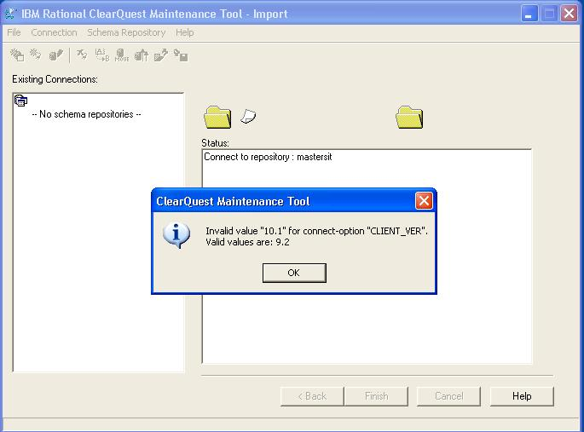

To resolve the issue Upgrade the Database schema version with current Oracle Version.

Needs to Upgrade the All the Databases to connect to Oracle Server from CQ Version 7.

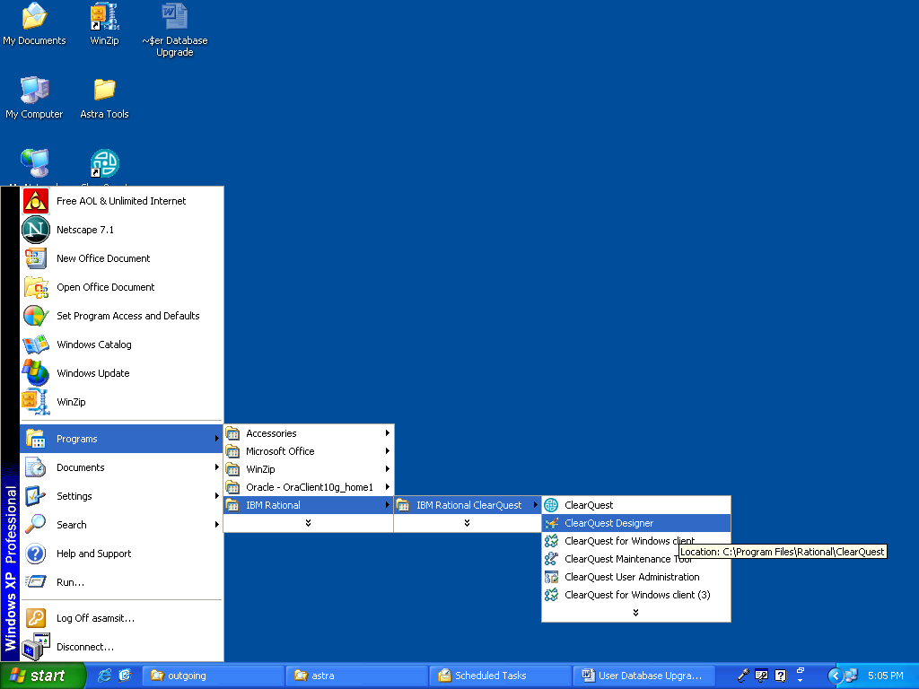

Database -> Update User Database Properties

Vendor: Oracle
Server: alcat134
SID: astra
UserName: Production
Password: wipro123
Connect Options:
HOST=alcat134;SID=astra;SERVER_VER=9.2;CLIENT_VER=9.2;LOB_TYPE=CLOB

Then click Update to update the database changes.

Similarly update all the user databases.

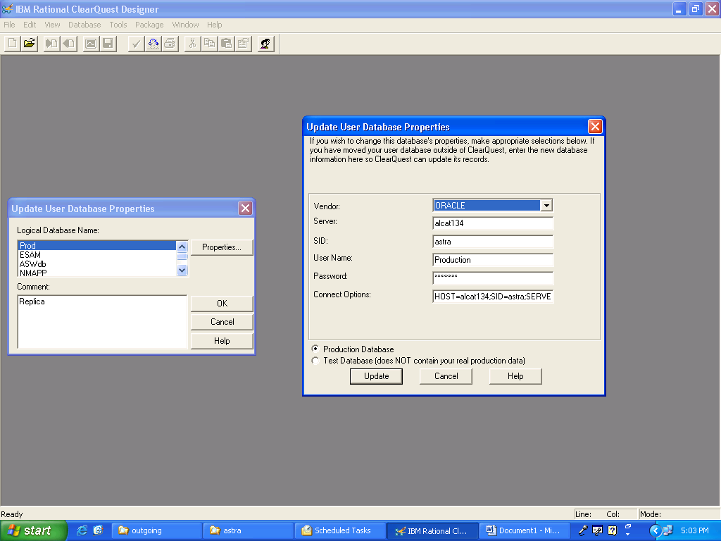

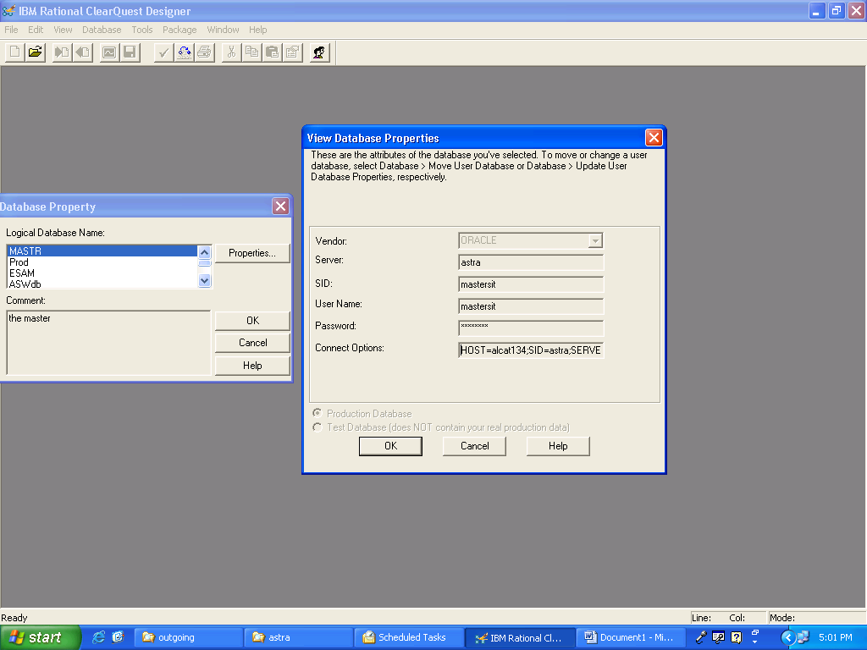

HOST=alcat134;SID=astra;SERVER_VER=9.2;CLIENT_VER=9.2;LOB_TYPE=CLOB
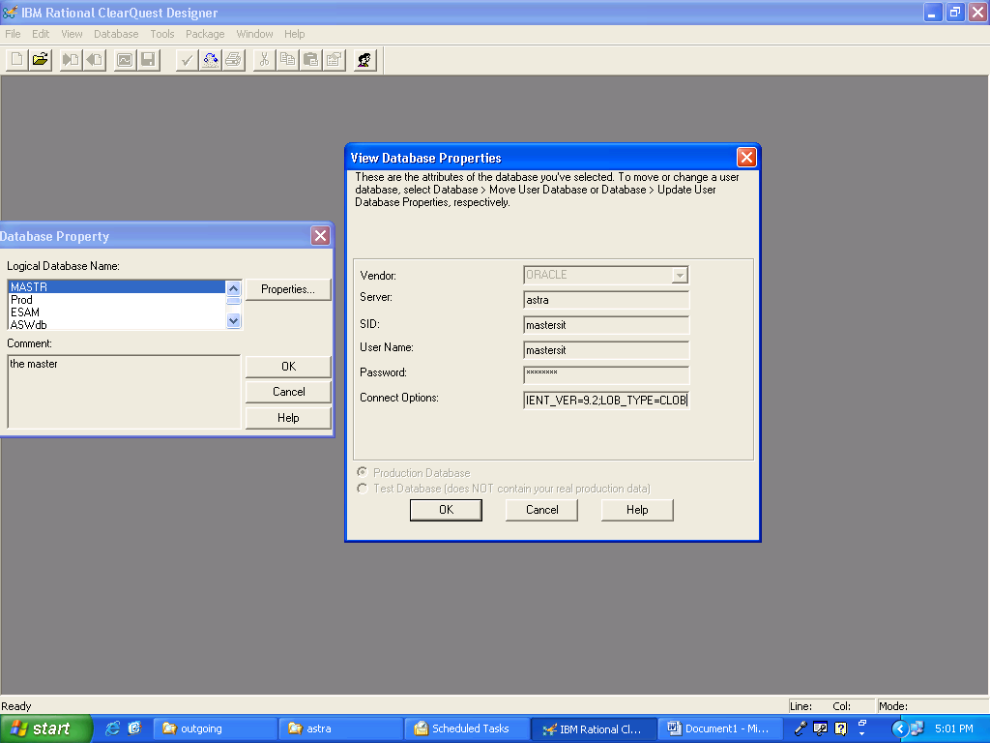

Now the changes got updated. Create a CQProfile and connect to the Database.

SQL> select name,description,METASCHEMA_VERSION,FEATURE_LEVEL,CONNECT_OPTIONS from mastersit.master_dbs;

NAME DESCRIPTION METASCHEMA_VERSION FEATURE_LEVEL CONNECT_OPTIONS MASTR the master 22 5
HOST=alcat134;SID=astra;SERVER_VER=9.2;CLIENT_VER=9.2;LOB_TYPE=CLOB

Prod Replica 22 5
HOST=alcat134;SID=astra;SERVER_VER=9.2;CLIENT_VER=9.2;LOB_TYPE=CLOB

ESAM Replica 22 5
HOST=alcat134;SID=astra;SERVER_VER=9.2;CLIENT_VER=9.2;LOB_TYPE=CLOB

ASWdb Replica 22 5
HOST=alcat134;SID=astra;SERVER_VER=9.2;CLIENT_VER=9.2;LOB_TYPE=CLOB

NMAPP Replica 22 5
HOST=alcat134;SID=astra;SERVER_VER=9.2;LOB_TYPE=CLOB

Train Replica 22 5
HOST=alcat134;SID=astra;SERVER_VER=9.2;LOB_TYPE=CLOB

6 rows selected.

SQL>

CQProfile.ini

[CQMS.ASTRA.BAN]
VendorString=ORACLE
Server=astra
DatabaseName=mastersit
DataOwnerLogin=mastersit
DataOwnerPassword=6082e332d300671777
ReadWriteLogin=mastersit
ReadWritePassword=6082e332d300671777
ReadOnlyLogin=mastersit
ReadOnlyPassword=6082e332d300671777
ConnectOptions=HOST=alcat134;SID=astra;SERVER_VER=9.2;CLIENT_VER=9.2;LOB_TYPE=CLOB

Oracle Database is connected to CQ Version 7.

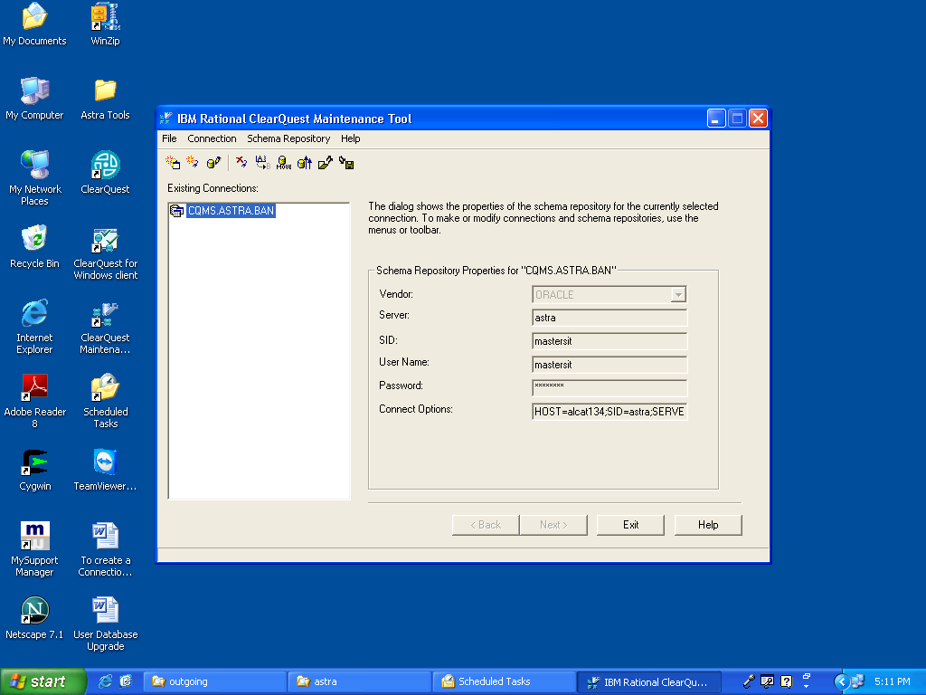

To create a Database Connection in CQ version 7.

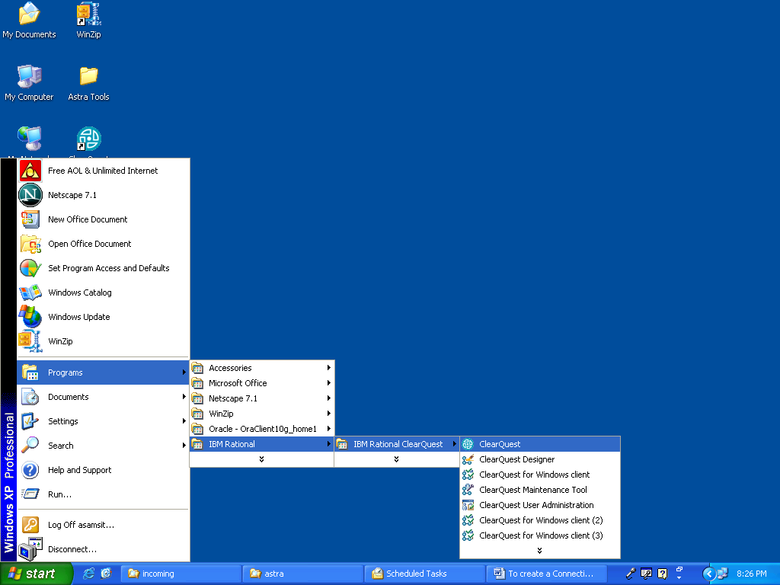

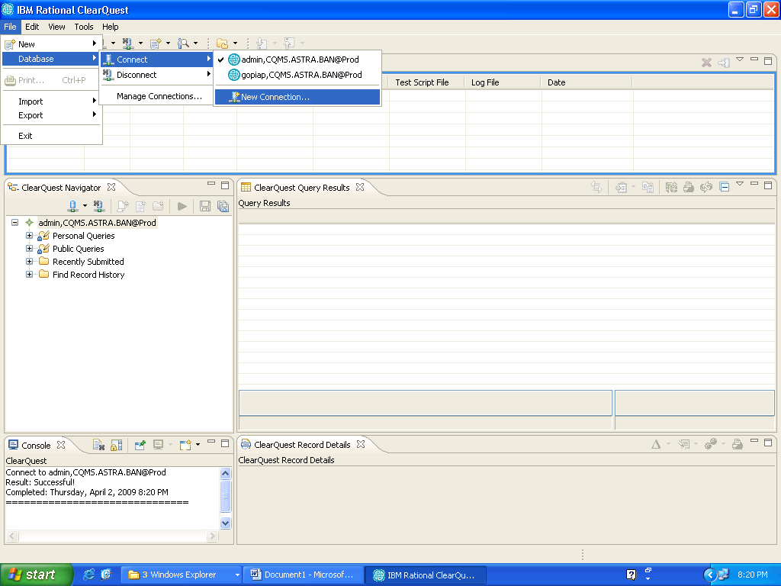

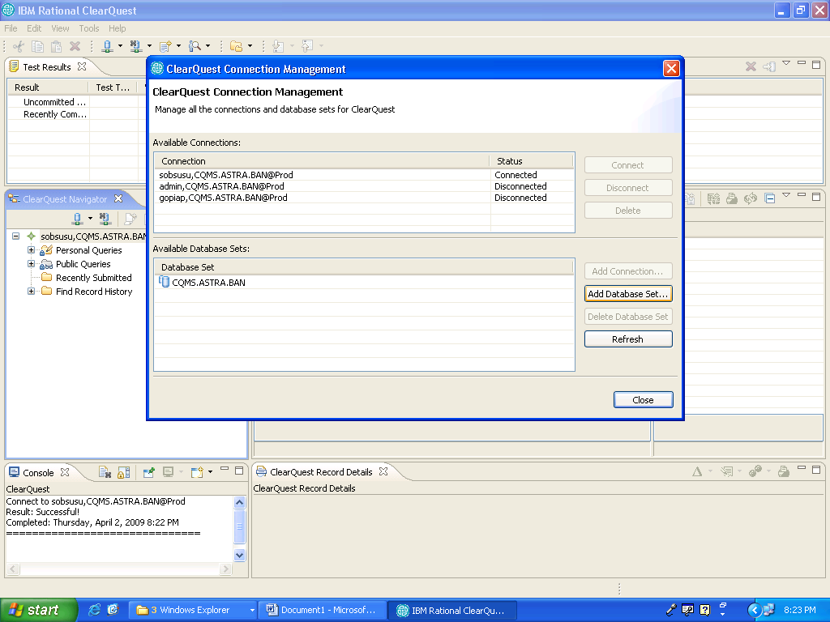

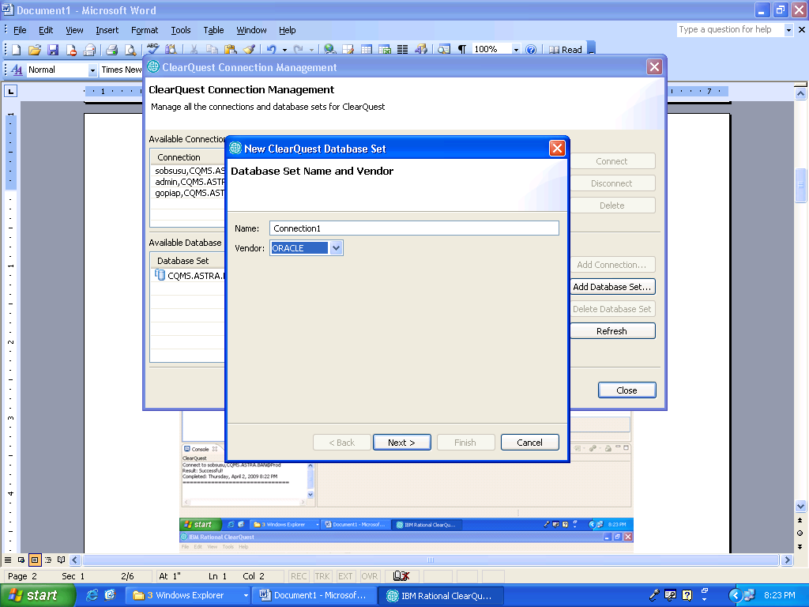

Then it will connect to ORACLE Database.
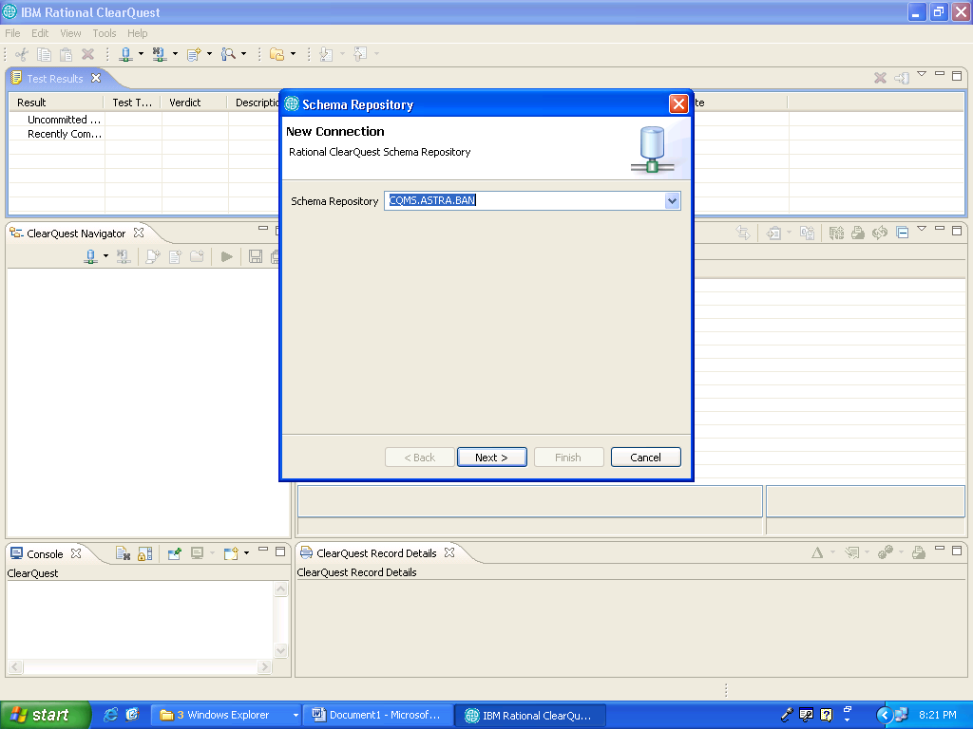

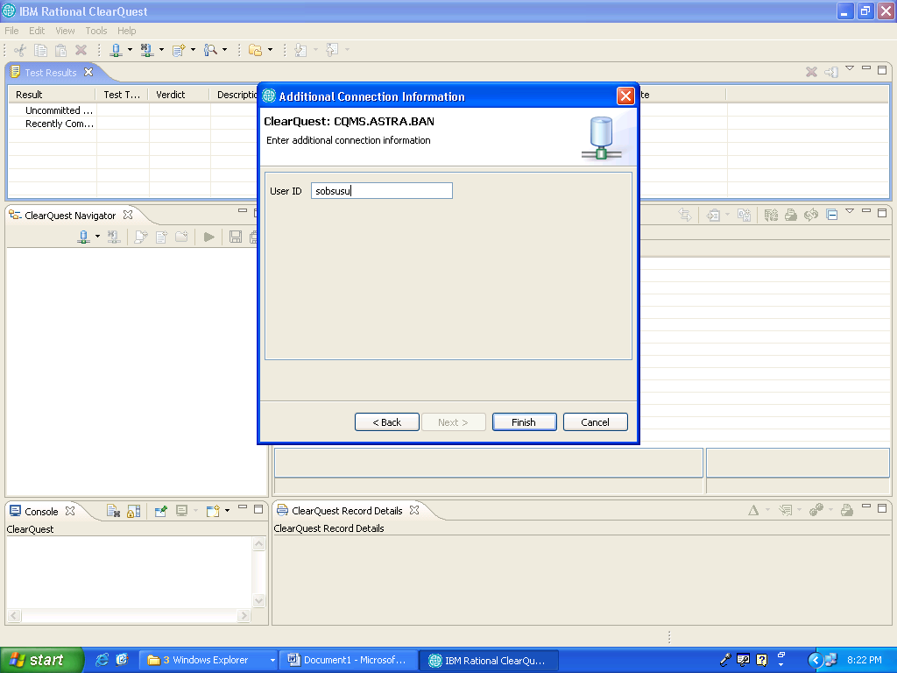

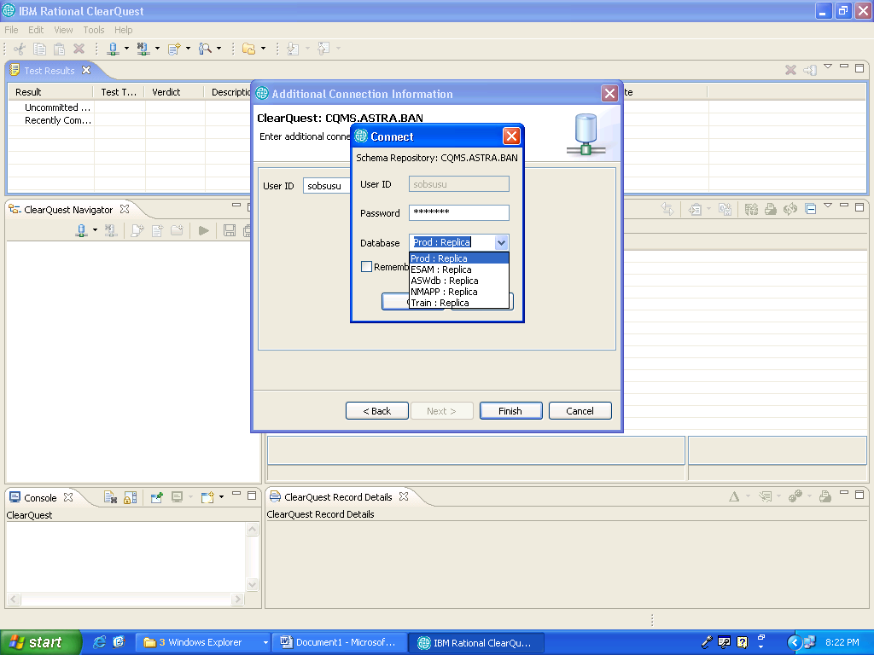

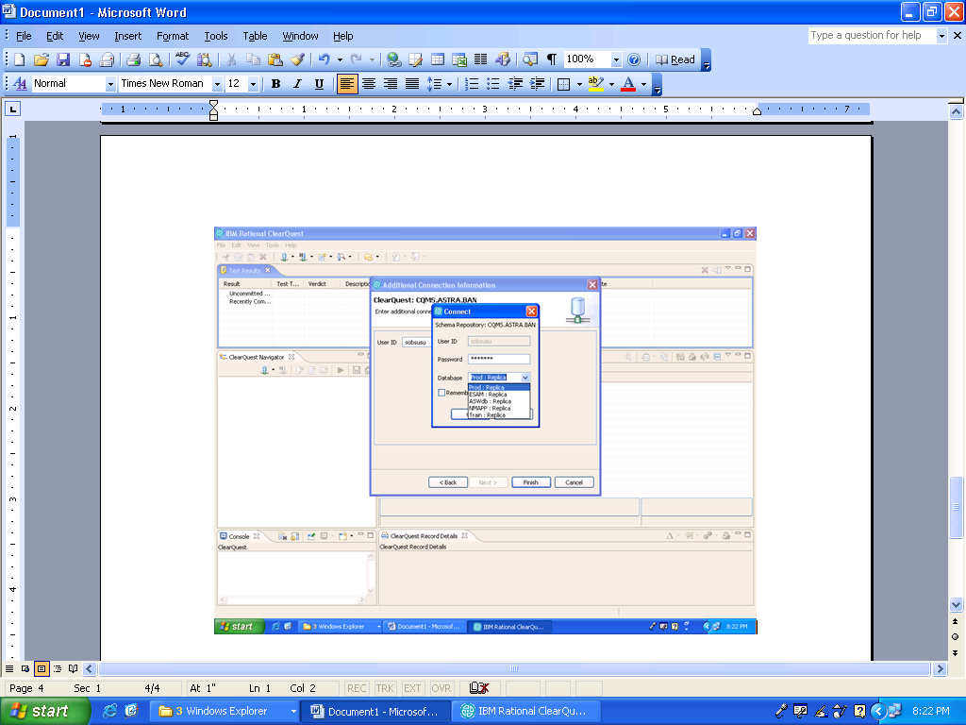

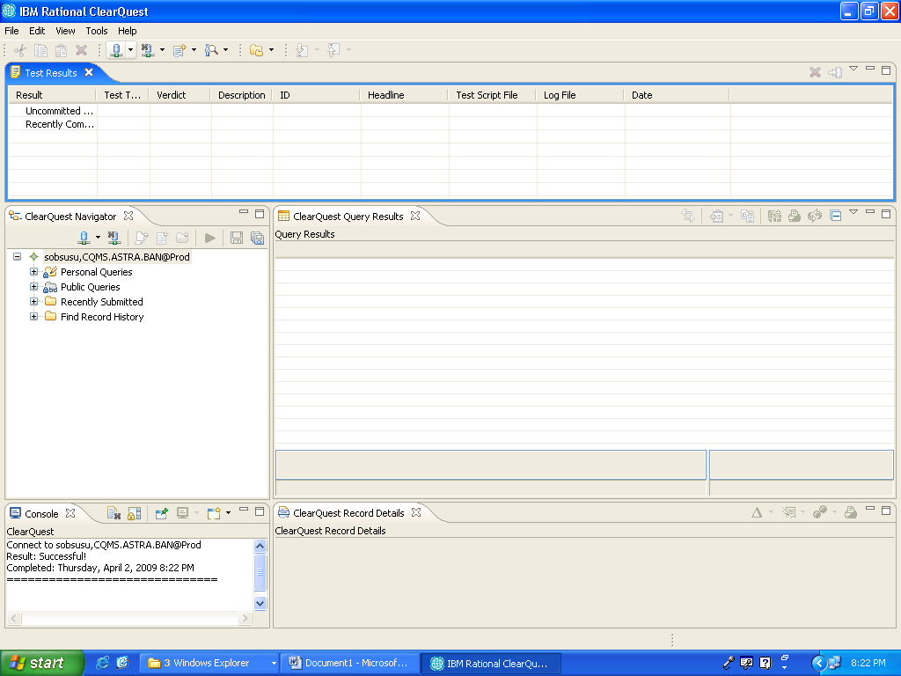

After creation connection needs to open IBM Rational Clearquest -> clearquest for windows client

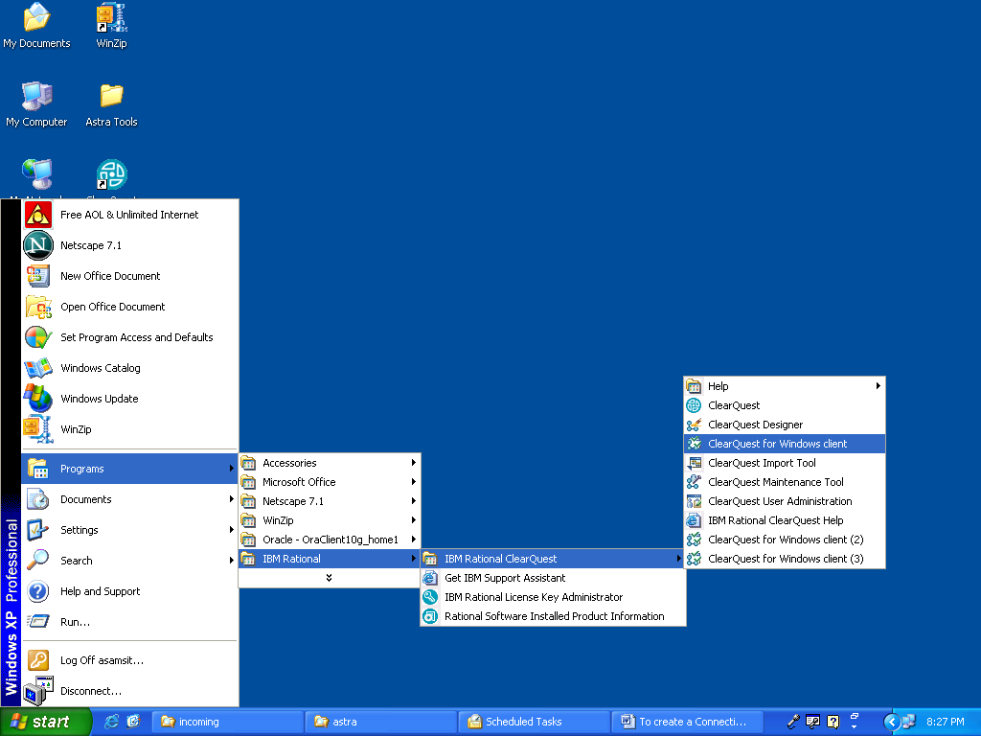

It will ask for admin login and password then window will open.
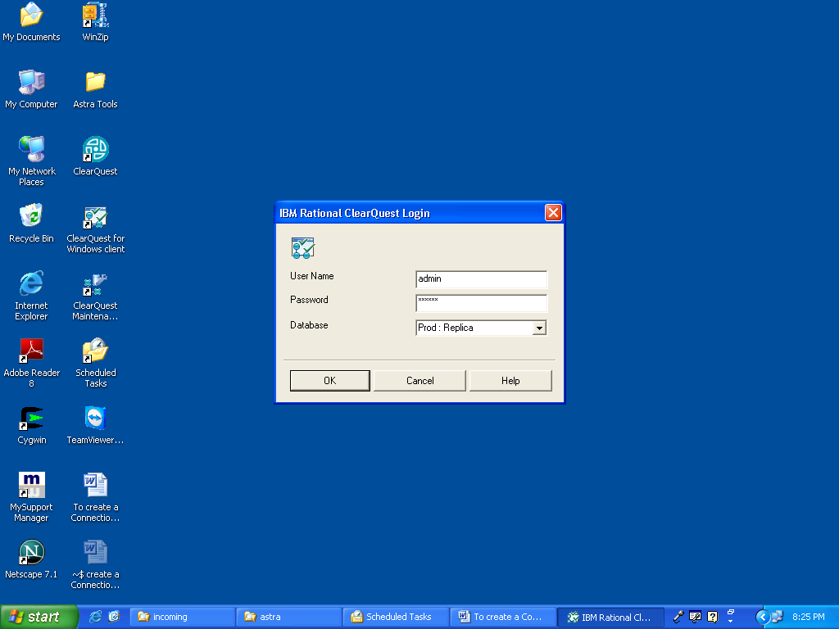

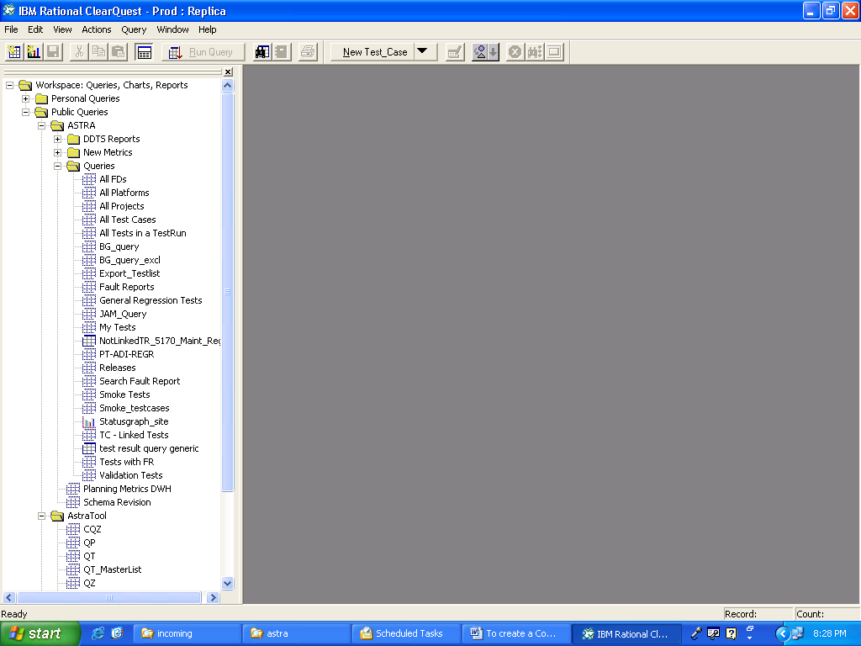

Successfully Connected to Database ☺

Map the Shipping Server to the network Drive => D:\

\\192.168.220.157\astra

Login: ccms_ftp
Pwd: vobs@asamvob1

Now Proceed with Sanity Testcase.

CQv7.0.1 upgradation Sanity TestCase

Sl.No. | TestCase | Expected Behavior | Test Behavior  (Ok/ Nok) | Remarks
1 | Check whether datatype converted from LONG to CLOB in Oracle Database  Command:  Select name,  connect_options  from master_dbs; | NAME CONNECT_OPTIONS  ----- -----------------------------  MASTR LOB_TYPE=CLOB;  Train SERVER_VER=9.2;LOB_TYPE=CLOB  ESAM SERVER_VER=9.2;LOB_TYPE=CLOB  NMAPP SERVER_VER=9.2;LOB_TYPE=CLOB  Prod SERVER_VER=9.2;LOB_TYPE=CLOB | Ok | Initially faced problem. After Rollback and oplog scrubbing issue was resolved
2 | Check CQv7.0.1 shipping server /Client database connection information in CQ Maintenance Tool | Vendor : ORACLE  Server :<Oracle server host name or IP Address>  SID : anddslam  User name: mastersit  Password: *********  Connect Options: LOB_TYPE=CLOB; | OK | Existing CQProfile was incompatible with existing DB.  Upgraded the all the database schema
3 | Check Master & all User Database Property information in CQv7.0.1 shipping server  CQ Designer-> Database-> View Database Properties | Vendor : ORACLE  Server :<Oracle server host name or IP Address>  SID : anddslam  User name: esam  Password: ****  Connect Options: SERVER_VER=9.2;LOB_TYPE=CLOB; | OK | Connect options are exactly as mentioned
4 | Check all CQ web services are running in CQv7.0.1 shipping server  Start->Run->services.msc | Rational CQ Registry server  Rational CQ request manager  Rational web platform HTTP server  RWP requestweb servlet engine  RWP servlet engine | OK | Running
5 | Check whether ASTRA Tool 6.3.6 or 6.3.4 is working with CQv7.0.1 client & CQv6 client | It should connect to all user databases without any errors. | OK | ASTRA Tool 6.3.3 successfully done
6 | Check whether ASTRA Planning Tool 3.1.0 is working with CQv7.0.1 client & CQv6 client | It should connect all user databases without any errors. | OK | Done
7 | Submit a new record (Testcase, Test, Release records etc)in Training database | It should not get any submission error and also it should be viewable without any errors. | OK | New Record created
8 | Modify a newly added record | It should allow you to modify the newly added record and changes needs to reflect immediately without any errors. | OK | Modified (Prod, Train)
9 | Delete the newly added record | Data should be removed from Database immediately without any errors. |  | Test (Testcase deleted)
10 | After enabling sync task in all sites, check whether sync export and import is working fine. | Packets should be export/import to others sites without any errors. | Ok | Packet generated successfully

ClearQuest Version 7 Migration Activity completed Successfully ☺

Updated By: Chandra
Date: 07-APR-09

